

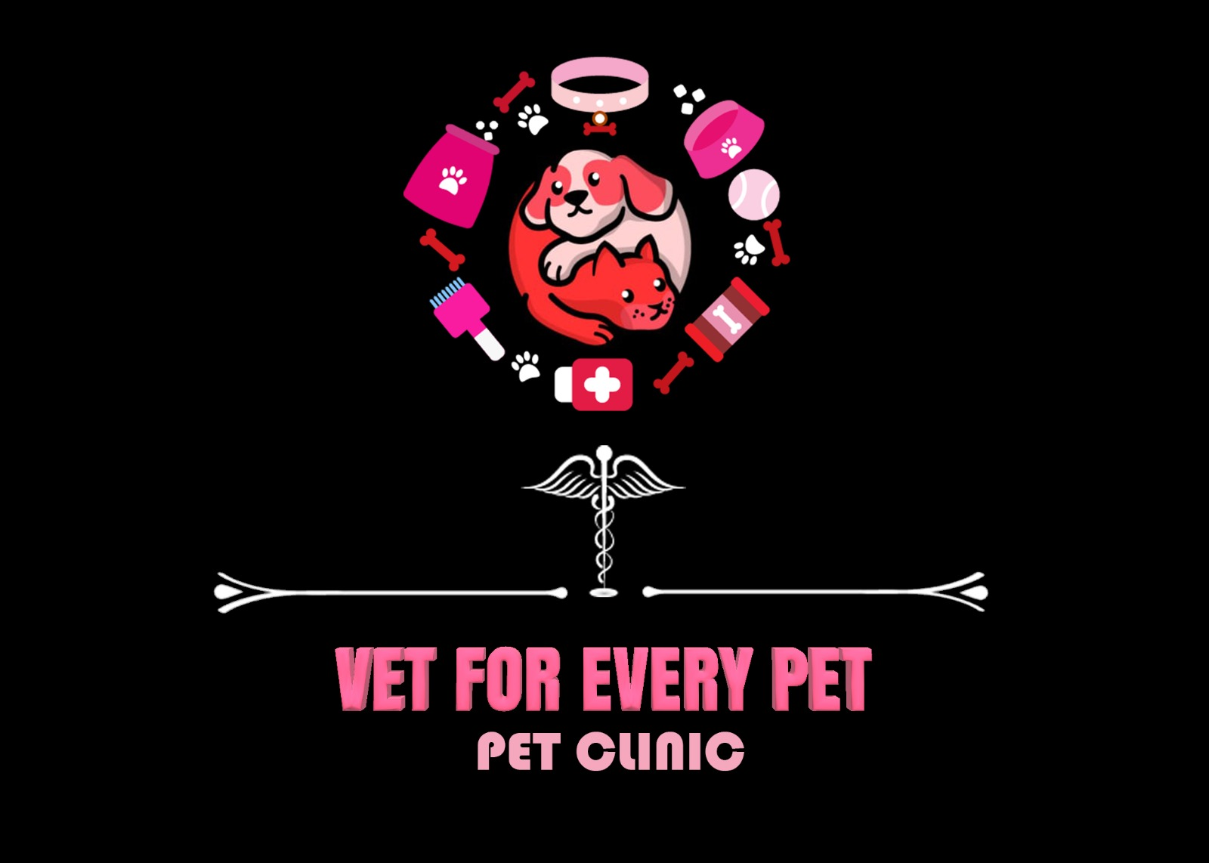

Nile University

Core Requirements

BMD303 Project’s-SP”22

*Vet For Every Pet*

*(Pharmacy & Pet Clinical Management System)*

# Done By:

|  |
| --- |
| **Shrouk Hesham Mahmoud - 19106271** |
| **Elzahraa Saeed Abdelhalim - 19106429** |
| **Login Darwish 19105985 -** |
| **Alaa Mamdouh -** |
| **Salma İsmail Nofal - 18101502** |
| **Salma Sameh Megahed - 202002800** |

# Under Supervision Of:

**Dr. Sahar Fawzy & Eng. Omnia Saeed**

**Table of Contents**

1. Introduction 3

2. Overview 4

2.2 Objectives 4

2.3 System Description 5

2.3.1 System description and analysis 5

2.4 System Users 7

2.5 Requirements…………………………………………………………………………………………………………………………………….8

3. Methodology 8

3.1 Methods Steps 9

3.2 UML Diagram 9

3.3 High Level architecture 9

4. Results 11

4.1 VFEP Website Results 11

4.2 Pharmacy Results 17

5. Discussion & Conclusion 21

6. Future Work & Suggestions………………………………………………………………………………………………………………24

# Introduction

Pet clinics are regarded as one of the most essential clinics owing to the significance of animal health since many people own pets and expose their children to these animals on a regular basis. In addition, the Pet history can't be found by using the old way of clinical system that is dependent on paper. Furthermore, the necessity for transforming the outdated pet clinical systems and actual demand has increased because of the new generation of produced technology. Finally, the system is required to keep track of patients, appointments, procedures, and medicines. Many veterinary clinics claim to provide excellent services but fall short of the compassion required in diagnosis, treatment, and recovery of pets. To close this gap, VFEP Clinic offers pet owners a range of services, including first aid and nursing care, dental treatment, immunizations, surgeries, Grooming and boarding, and Diagnostic equipment. These were implemented together to give access to the doctor and the receptionist to manage all the required through the examination process. As for the pharmacy, we started to implement a pharmacy management system to make our system bigger, detailed, and integrated. A pharmacy management system integrated with a pet clinic system is a software solution that aims to streamline the process of managing medication and treatment for pets. This system combines the functionality of a pharmacy management system with a pet clinic system to create a comprehensive platform that allows veterinary clinics to manage their inventory, prescriptions, and treatment plans in a more efficient and organized manner.

# Overview

Developing a desktop program for managing veterinarians’ workflow, keeping track of pets, appointments, procedures, and medicines. We added two other interfaces beside the clinic system which are “Vet for Every Pet website” and “Pet Heaven Pharmacy”, so they can function together and share pets’ information to enhance supply chain management. The integration is done by using API. Additionally, supporting more data formats and, therefore, simplifies our software integrations and interoperability for our healthcare. With the help of this software, veterinary clinics can simply manage the prescriptions, drugs, and the offered services for the pets, ensuring that they get the proper care at the appropriate time. The software may create prescription labels and instructions, keep track of inventory levels, and replenish medicines as needed. The website on the other hand works as a display for pet owners to show them the functionality of our system and the offered services as well as the doctors who are responsible for each one of these services and the process that their pet goes through. The safety of the pets in your care can also be ensured by notifications for potential drug interactions or restrictions.

# Objectives

* Provide decision support for doctors.
* Developing independent systems with the functionality each department in the hospital needs, while connecting and integrating all these systems to make data exchange between them easier.
* Coordinating the workflow of the veterinarians, including keeping track of the animals, appointments, treatments, and medications.
* Each Pet's profile is saved in the system database, making it simple to locate, manage, and update regularly.
* Supporting more data formats makes it easier to integrate software and achieve interoperability in the healthcare sector.

# System Description

## 2.3.1 System description and analysis

* Once the user opens the desktop application system, he/she is required to declare his/her role whether admin, receptionist, or doctor, and will access the system with their username and password.
* If the user is an admin, he/she can add, edit, and delete receptionists’ and doctors’ data (name, phone, gender, date of birth, address, and password).
* To make an appointment whether normal or emergency, the receptionist should add the pet’s name, gender, age, pet allergies, and for sure some data of the pet owner such as address and phone to contact him/her to check the pet medical updates and if there is some extra test. The system enables receptionists to edit and delete these data.
* The clinic offers the supplies that pets need such as “dry food”, “toys”, and “accessories”, and all whatever pets need. All it needs to be done is just the receptionist to access the “supplies windows” and add them to the pet.
* The doctor form is mainly about what the doctor might use during the diagnosis. It's including the pet Id and name and the other mandatory enters such as the medicine entry, gender, any type of test that the pet had done, and the extra text box that the doctor might need to add any other type of information that will help him during the diagnosis.
* The system has a dashboard window that shows the statistical data such as how many pets and doctors are in the system, prescriptions, the amount of these prescriptions, and the highest pets category. These statistical data change over adding, editing, or deleting.
* The icons in the system are transitions that ever access responsible for each user the system which means that the admin has access to all the forms in our system (receptionist form, doctor form, login/out form), and the doctor has the access to the prescription form and the dashboard form, and the receptionist has the access to the pet form, and the dashboard.
* The pharmacy system has just one role “pharmacist” who can only access the system. After the doctor diagnoses the pet and recommends suitable medicines, with integration all pet’s information appears in front of the pharmacist, and the pharmacist immediately searches for the pet’s medicines and calculates and prints the bill and gives it to the pet owner.
* The pet clinic website has several services that can benefit both the pet and its owner such as dentistry, grooming, diagnostic equipment, preventive care and treatment, resources, and surgical services. These services helped the doctor as well.

# System Users

|  |  |
| --- | --- |
| **USER** | **Tasks** |
| **Admin** | * Add-edit users like doctors, pharmacists, and receptionists. * Monitor the system activity, security, performance, and system backup. * Maintain System and database, System Backup. |
| **Receptionist** | * Access the system after entering their username and password. * Add- Edit account of pet details and pet owner. * Add details of pets’ appointments date and times. * Review the pets' records by searching their owners and reviewing the history of pet cases. * Add supplies. |
| **Doctor** | * Access the system after entering their username and password. * Review the pets' records by searching their owners and review history of pet cases. * Diagnosis the pet medical condition * Input medical drug. * Document any note related to the state. |
| **Pharmacist** | * Get the pets’ medicines and vaccinations by searching according to the prescription. * Make the bill for medicines. * Print the bill. * Get the required supplies |

# 2.5 Requirements

* **2.5.1 Functional:**
  + **Adding Patients:** The front desk staff at the vet for every pet (VFEP) clinic can add new animals to the clinical database.
  + **Removing ID:** When a pet leaves the VFEP clinic, the personnel in the administrative area of the ward has the ability to remove the pet's ID from the database.
  + **Updating information of the Pet:** The VFEP clinical system enables users to update the information of the pet as described in the mandatory information included.
* **2.5.2 Non-Functional:**
* **Serviceability:** The application must be programmed such that the developer can fix it again if an issue develops in the clinical System.
* **Data Reliability:** The VFEP clinical management system must contain only correct and trustworthy data.
* **Recoverability:** A reliable data backup method must be included in the VFEP clinical management system.
* **Performance:** The VFEP clinical management system must function successfully in a variety of scenarios.
* **Maintainability:** High maintainability standards must be met by the VFEP health care system.
* **Backup:** The system leverages its effectiveness to store data.
* **Failures:** The system will keep track of all errors and keep a record of them.
* **Usability:** The user interface of the VFEP clinical management system must be visually appealing as well as efficient.
* **Manageability:** When a recoverable interruption occurs in the VFEP clinical management system, Alerts are required to be sent out.
* **Security:** Proper usernames and passwords must be used for security purposes in the VFEP clinical management system.
* Users must have a **Login ID** and **password** in order to log in to the system.
* **Modifications:** The VFEP administrator is the only person who can make changes to the database, such as inserting, deleting, or updating information.
* **Front Desk Employee Rights:** The front desk employees can examine any data in the VFEP Management system and add new records, but they do not have the authority to make any changes to the system's data.

# Methodology

Designing a desktop application for managing a veterinarian's workflow, tracking pets, and integrating with a pharmacy by using Net Framework, C#, ASP.net and Microsoft SQL Server. Vet For Every Pet website using C#, ASP.net MVC, HTML\CSS, jQuery, JavaScript, and Facebook API. **The methods steps were as Following:**

**1. Gathering and Analysis:**

- Understand the specific needs and requirements for managing the veterinarian's workflow and tracking pets.

- Identify the necessary features and functionalities for appointment scheduling, patient records management, prescription tracking, and integration with a pharmacy and web clinic website.

- Determine the data formats and integration standards required for seamless connectivity with the pharmacy and web clinic website.

- Define the scope of the project, including the target platforms, technologies, and development frameworks (e.g., C#, ASP.NET, Microsoft SQL Server).

**2. System Design:**

- Design the architecture of the desktop application using the .NET Framework, C#, and Microsoft SQL Server.

- Identify the modules and components required for managing the veterinarian's workflow, pet tracking, and integration with the pharmacy and web clinic website.

- Define the database schema for storing pet information, medical records, appointment details, prescriptions, and other relevant data.

- Creat desktop application and ensure a user-friendly interface for efficient workflow management.

**3. Desktop Application Development:**

- Implement the desktop application using C#, ASP.NET, and the .NET Framework.

- Develop modules for appointment scheduling, patient registration, medical record management, prescription tracking, and other required functionalities.

- Integrate the application with the pharmacy and web clinic website using appropriate APIs to facilitate seamless communication and data exchange.

**4. Testing:**

- Conduct unit testing to verify the functionality of individual modules and components.

- Perform integration testing to ensure proper communication and data exchange between the desktop application, pharmacy, and web clinic website.

- Conduct system testing to evaluate the overall performance, reliability, and usability of the application.

- Collaborate with the veterinarian to gather feedback and make necessary improvements.

**5. Deployment and Maintenance:**

- Prepare the desktop application for deployment on the veterinarian's machines, considering the target operating system and hardware requirements.

- Provide documentation and training materials to facilitate the adoption and effective use of the application by the veterinarian and their staff.

- Monitor the application's performance and address any issues or bugs that may arise.

- Regularly update the application to incorporate new features, security patches, and improvements based on user feedback.

**6. Vet For Every Pet Website Integration:**

- Develop a separate module or application using C#, ASP.NET MVC, HTML/CSS, jQuery, JavaScript, and the Facebook API for integrating with the Vet For Every Pet website.

- Design and implement the necessary APIs to facilitate data exchange and integration between the desktop application and the website.

- Ensure seamless synchronization of data between the desktop application and the web platform, allowing for efficient management of appointments, pet information, and other relevant data.

**7. Pharmacy and Web Clinic Website Integration:**

- Develop separate modules or applications using appropriate technologies (e.g., APIs, web services) to integrate the desktop application with the pharmacy and web clinic website.

- Define the data exchange formats and protocols required for seamless integration.

- Implement APIs or web services to enable communication between the desktop application and the pharmacy, facilitating prescription management and order processing.

**8. Continuous Improvement:**

- Regularly evaluate the desktop application's performance and usability to identify areas for improvement.

- Stay updated with the latest technologies and industry trends to incorporate new features and functionalities that enhance the veterinarian's workflow.

Gather feedback from users, veterinarians, and stakeholders to understand their evolving needs and incorporate their suggestions into future updates and releases.

## 3.2 UML Diagram

## 3.3 High Level architecture

# Results

# Let’s see our Pharmacy & Pet Clinical Management System:

## VFEP Website Results:

This is the main page showing brief info about the clinic.

Medical Examination and Consultant is one of our services.

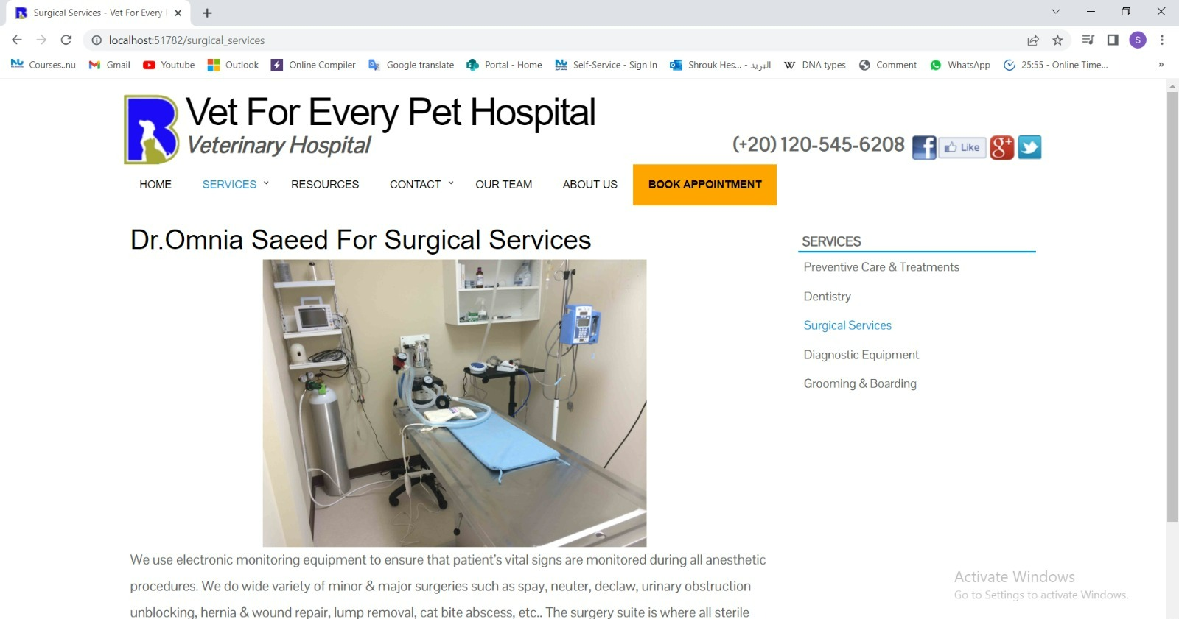

We offer surgical services as well with a brief on our equipment.

We can operate a dentistry on pet if needed.

Here we show our diagnostic equipment to the owners so that they can acknowledge our methods.

We offer grooming services for pets too.

Here is a list of the clinics we work with

The owner can contact us if he has any inquire.

Home Page for our project

## Pharmacy Results

The first page we implement consists of three lists, every list from them has an independent page. List Of Medicines, List of Prescriptions, List of Orders. This page will appear directly after the code is running as follows.

After that from these options, if we click on List of Medicines, the screen that will appear in front of us is as follows.

As we see in front of us, the medicines page shows us the Name of the medicine, Medicine Type, Price, Amount, and it allows us to Edit/Delete any medicine I want.

Add medicine function.

Edit medicine function.

Delete medicine function.

When we choose to remove or delete the medicine prescription, this screen will appear, and then we click “Delete”.

As we show, the pet medicine prescription contains Pet Name, Species, Gender, Color, Age, Weight, Medication name, Medication quantity, Prescription number. And have function called “Add new Prescription”.

Add prescription function.

# Disscusion & Conclusion

In summary, a pharmacy management system and a website are integrated with a pet clinic system developed using C#,ASP.net, MVC, HTML/CSS, JQuery/Javascript, Facebook API. is an advanced software solution that can help veterinary clinics improve their efficiency, accuracy, and patient care. With its range of features and user-friendly interface, this system can streamline the management of pet health and medication, allowing veterinary staff to focus on providing quality care to their patients and their owners. **Overall, the designed desktop application has successfully addressed the veterinarian's workflow management and pet tracking needs. The integration with the pharmacy and web clinic website has enhanced the application's capabilities and provided a comprehensive solution for veterinary clinics.**

1. **Future Work & Suggestions**

In our future work, enhancements and improvements to the desktop application will be added like developing a mobile application version of the veterinary management system to provide veterinarians and staff with on-the-go access to critical information, such as appointment updates, patient records, and prescription management. In addition to, telemedicine Integration explore the integration of telemedicine capabilities within the application to allow veterinarians to remotely diagnose and treat certain conditions. This would provide convenience for pet owners and expand the reach of veterinary care.